Pre requirements:

**JAVA 17 or 21 version**

**Download link for java 17: [Java Archive Downloads - Java SE 17.0.12 and earlier](https://www.oracle.com/java/technologies/javase/jdk17-archive-downloads.html)**

**Url:https://www.oracle.com/java/technologies/javase/jdk17-archive-downloads.html**

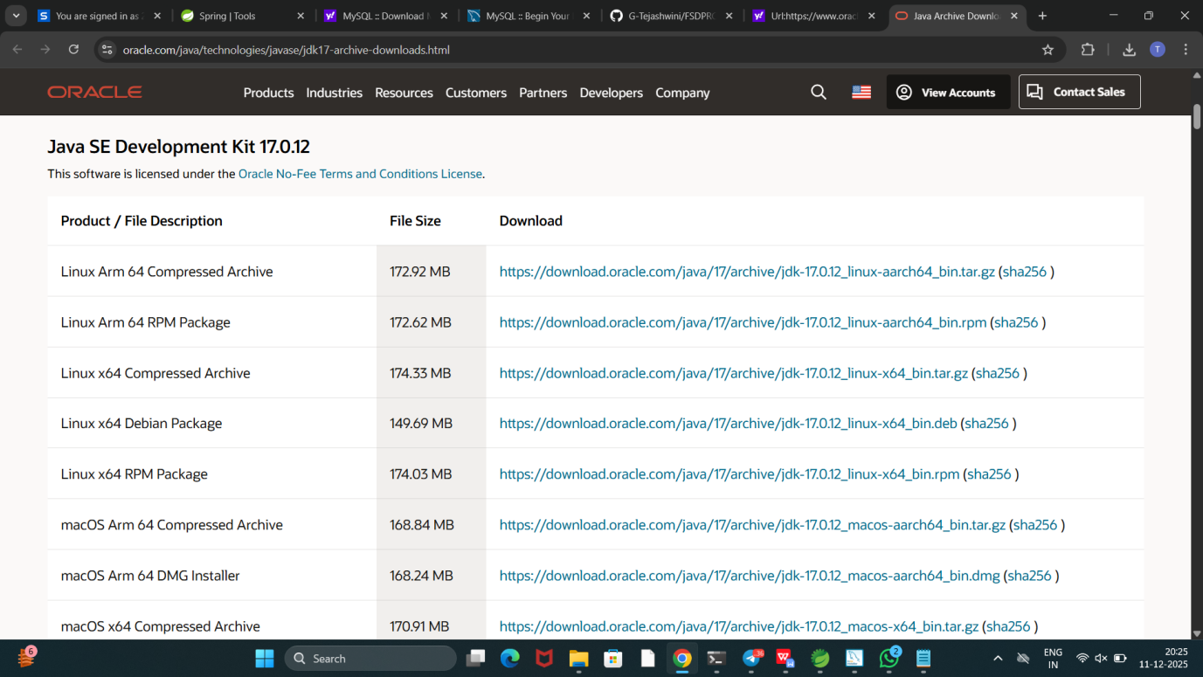

**Download and install windows x64 MSI installer**

**Url for spring tools suite:[Spring | Tools](https://spring.io/tools)**

**https://spring.io/tools**

**Choose spring tools for eclipse**

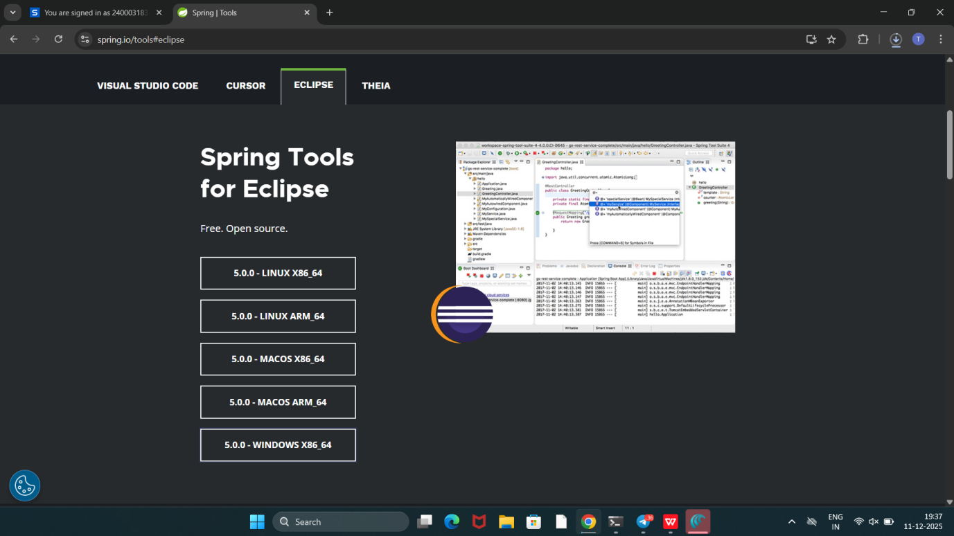

**Download**

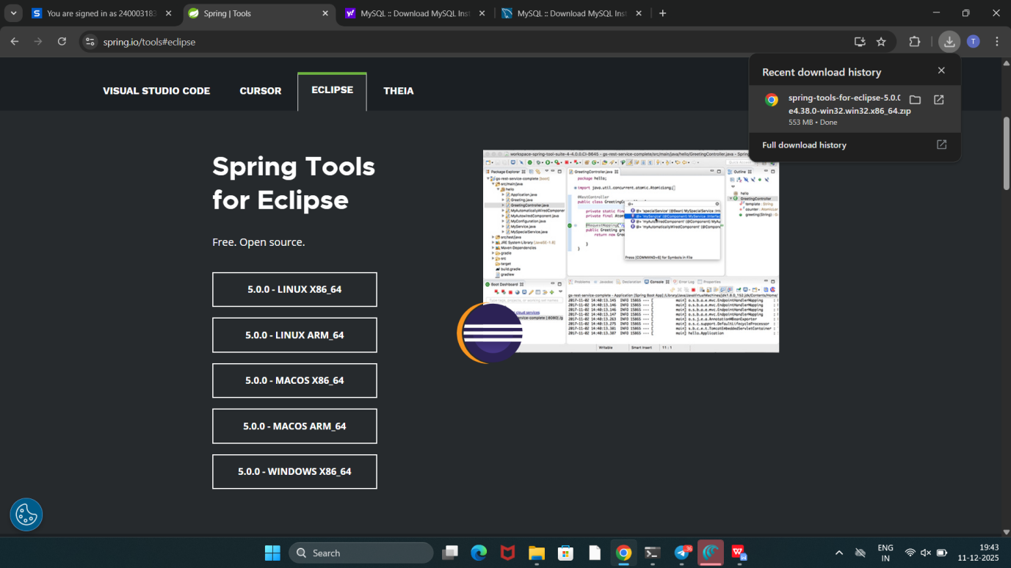

**After download open folder where it got downloaded**

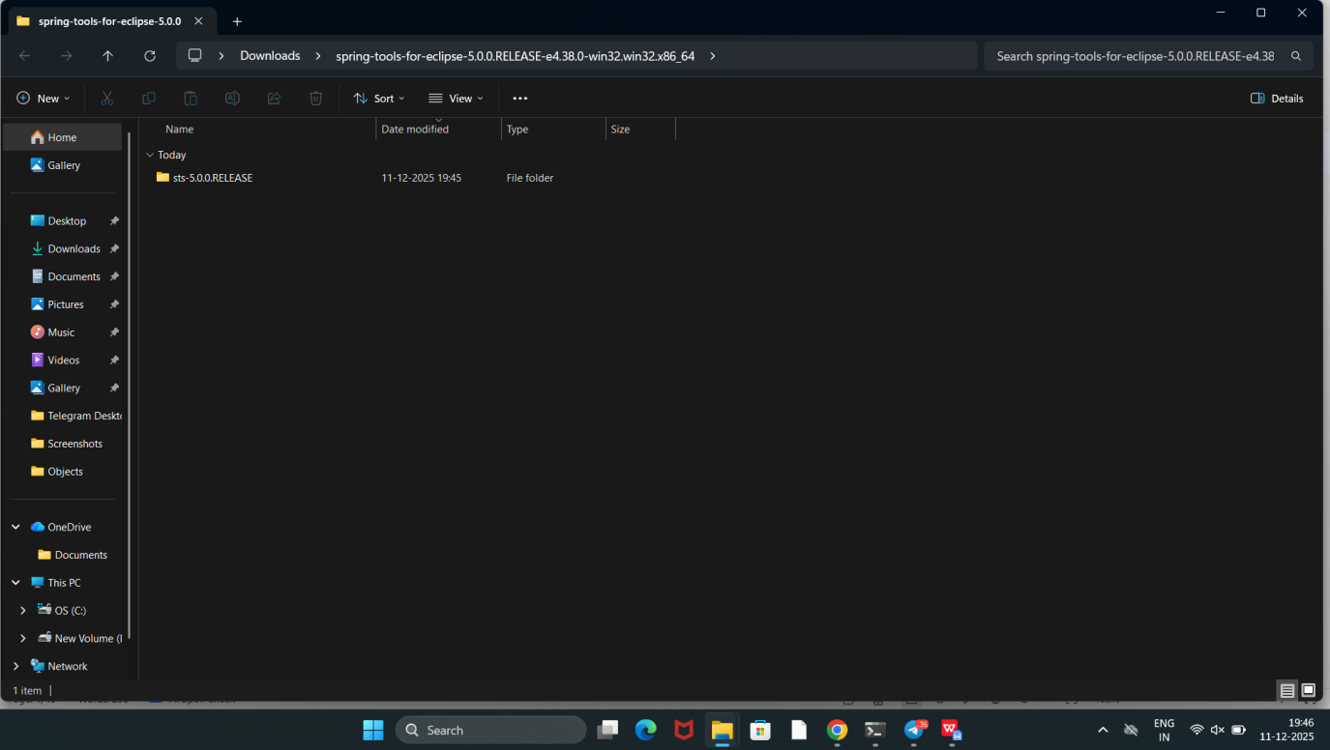

**Then click extract all option**

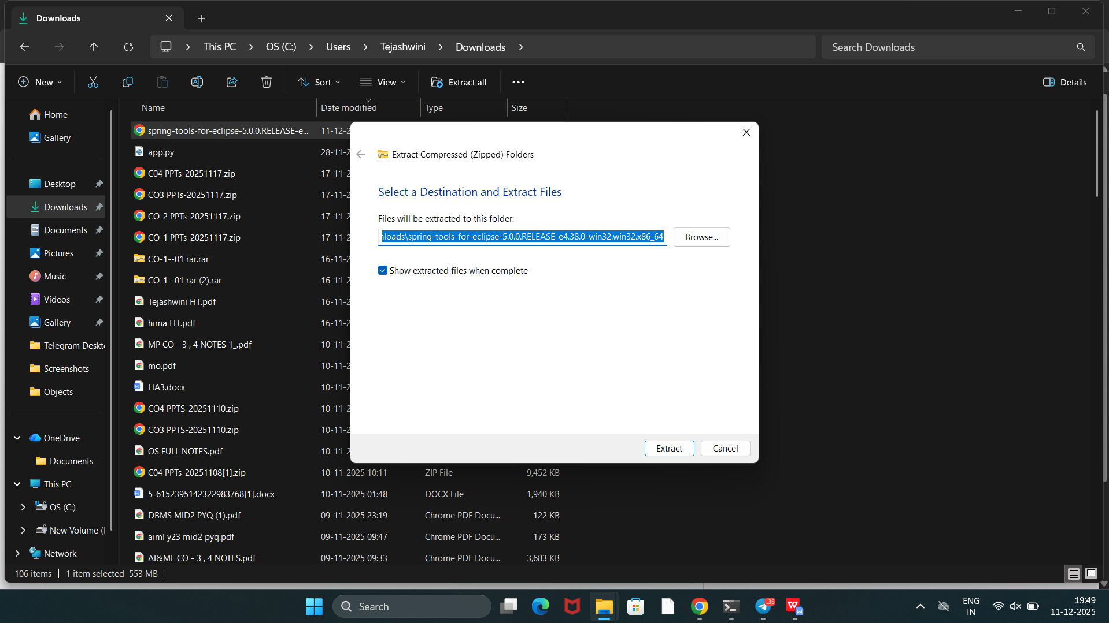

**Click browse button**

**And choose location : C:\Windows**

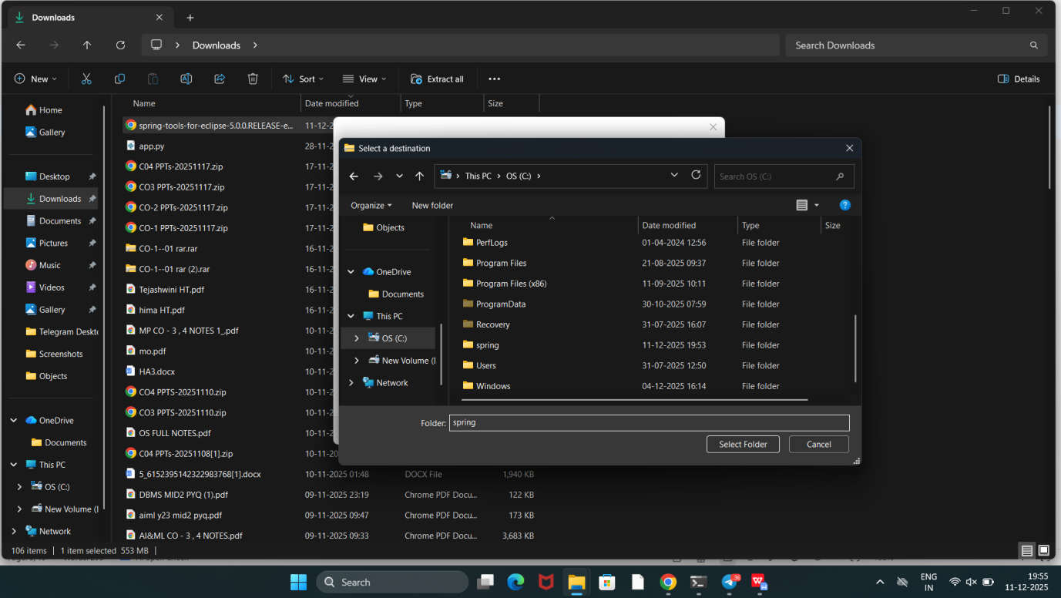

**Windows C:\Spring**

**Make a new folder Spring**

**And Extract all files**

**Finally you get**

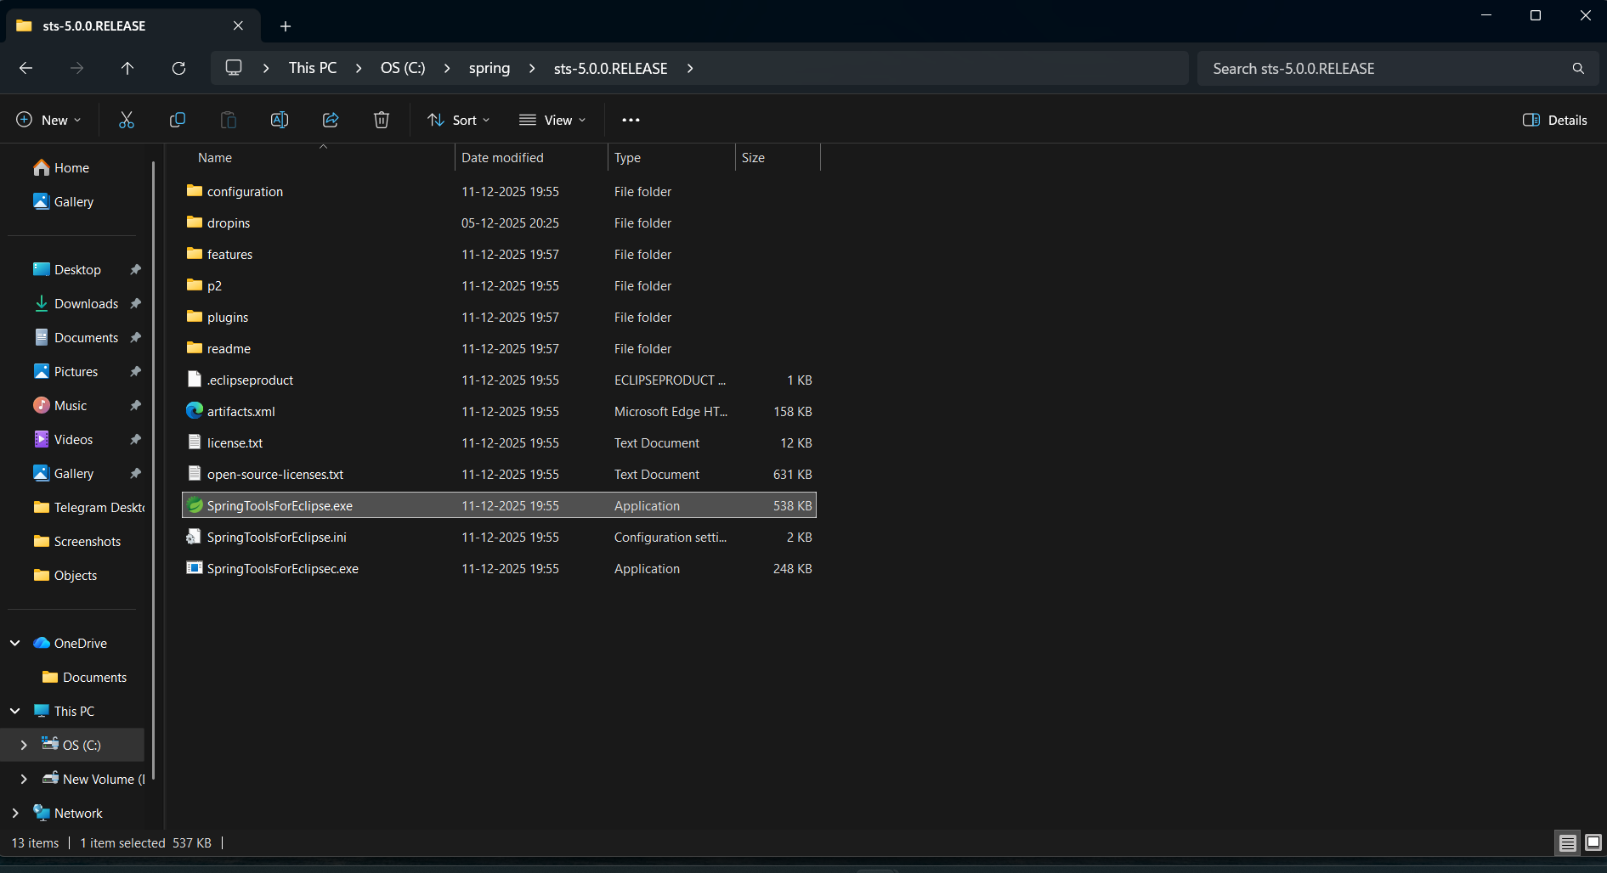

**Click spring tools suite4 Application with green color icon**

**And click launch**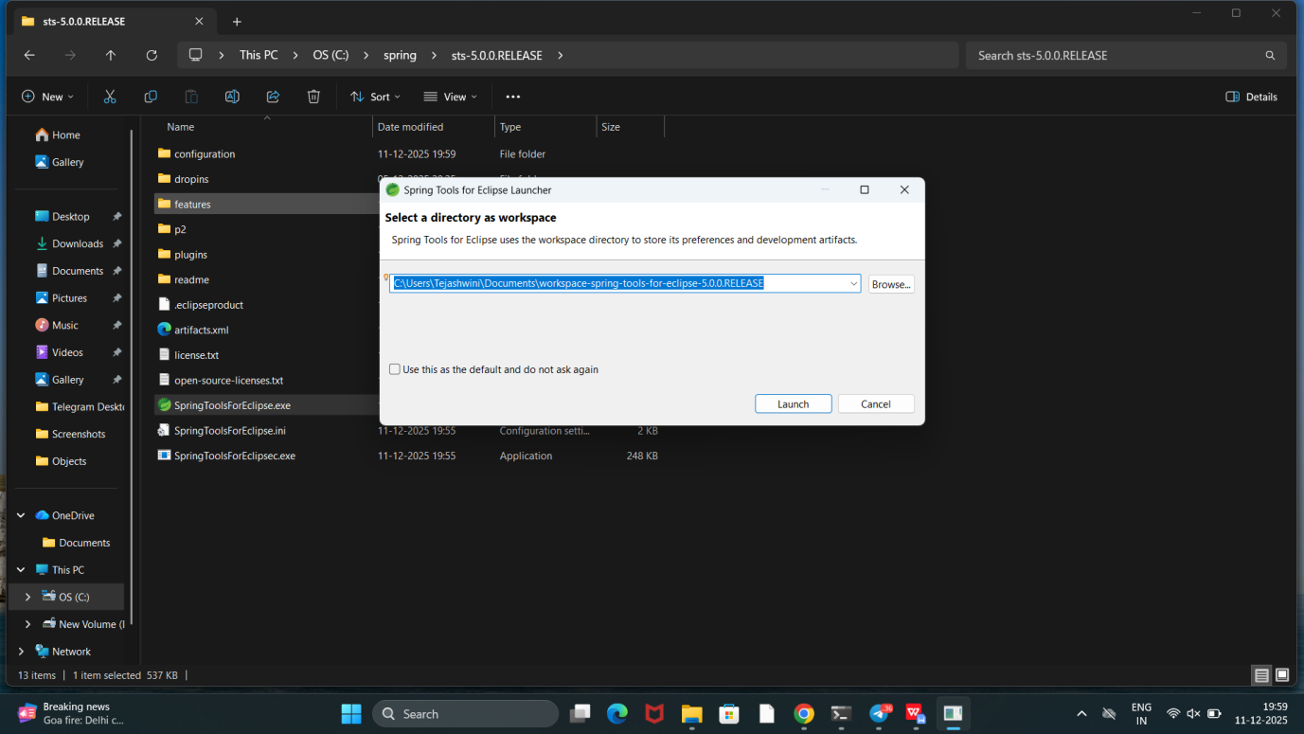

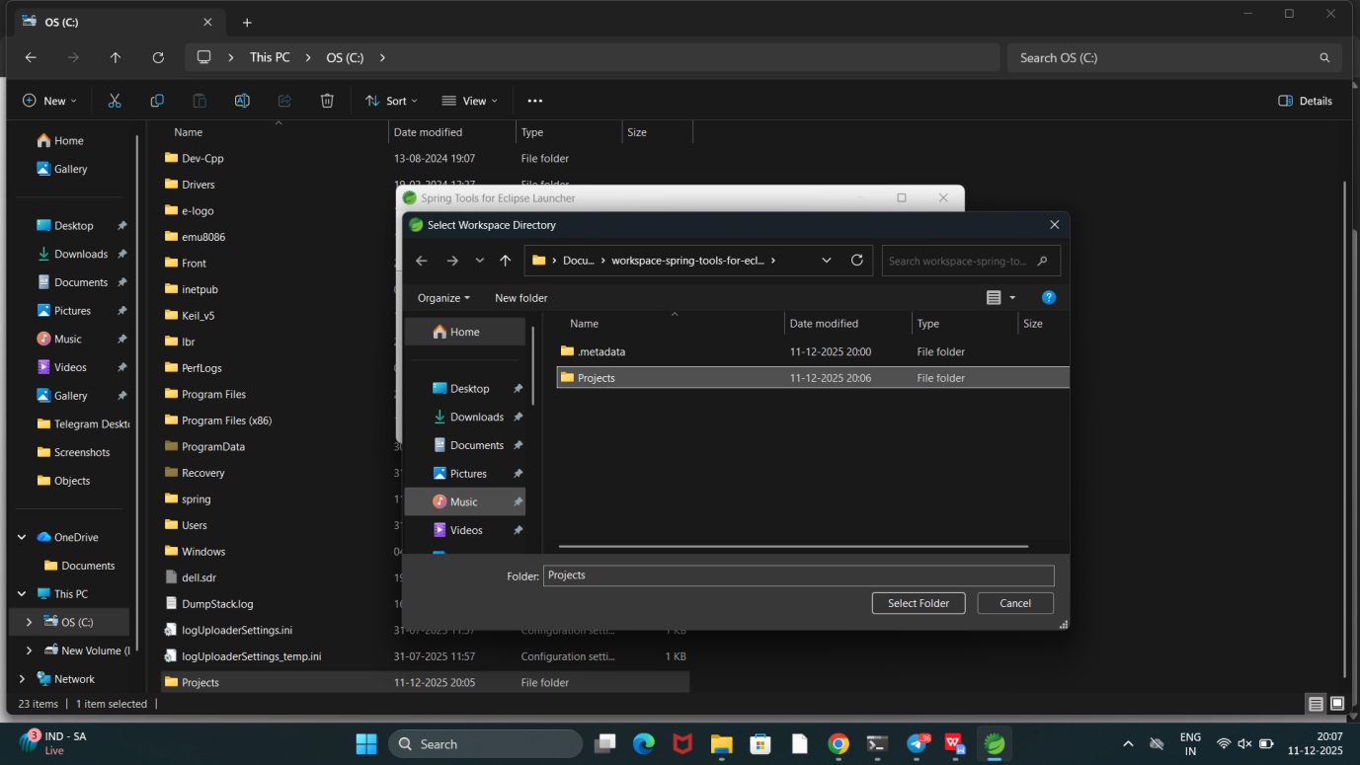

**Create “Projects” folder and add that as workspace folder by clicking “Select Folder button”**

**Click launch**

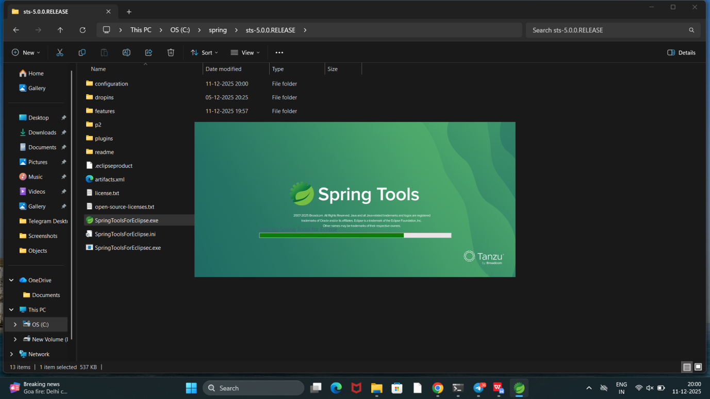

**Full window of spring tools looks like**

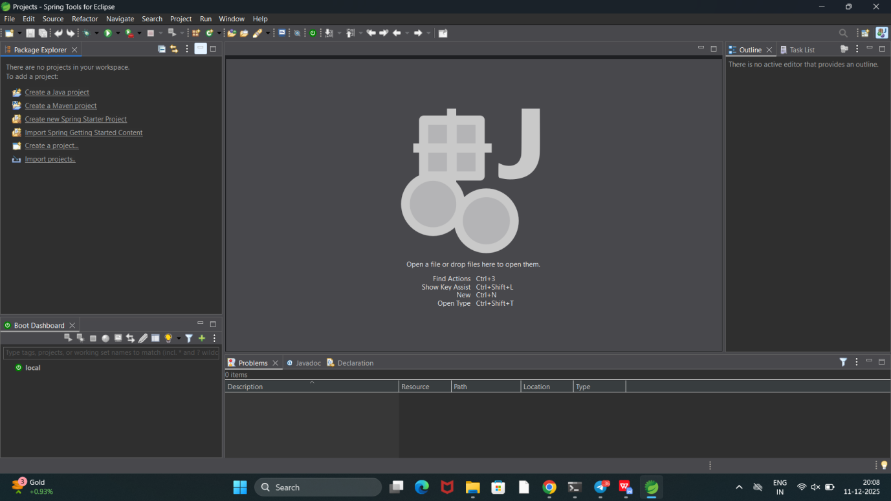

**Installation Completed Successfully**